Perfect Number
A number for which sum of all its factors is equal to twice the number is called a perfect number
Example
1) 6
The factors of 6 are 1, 2, 3 and 6.
Now, 1+2+3+6 = 12 = 2 × 6.
2) 28
All the factors of 28 are 1, 2, 4, 7, 14 and 28.
Now, 1 + 2 + 4 + 7 + 14 + 28 = 56 = 2 × 28.
Prime Numbers
The numbers other than 1 whose only factors are 1 and the number itself are called Prime numbers.
Example:
2, 3, 5, 7, 11 ,13
We can find list of prime numbers till 100 using Sieve of Eratosthenes method
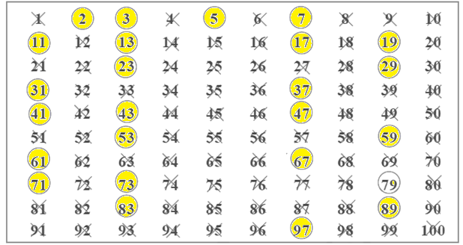
Step 1: Cross out 1 because it is not a prime number.
Step 2: Encircle 2, cross out all the multiples of 2, other than 2 itself, i.e. 4, 6, 8 and so on.
Step 3: You will find that the next uncrossed number is 3. Encircle 3 and cross out all the multiples of 3, other than 3 itself.
Step 4: The next uncrossed number is 5. Encircle 5 and cross out all the multiples of 5 other than 5 itself.
Step 5: Continue this process till all the numbers in the list are either encircled or crossed out.
All the encircled numbers are prime numbers. All the crossed-out numbers, other than 1 are composite numbers

Composite Numbers
Numbers having more than two factors (1 and itself) are called Composite numbers
Example:
4, 6, 8 ,9….

Even Numbers
The numbers which are multiple of 2 are called even numbers
Example
2,4,6,8,10,12,14
Even numbers have 0,2,4,6,8 in it one’s place

Odd Numbers
The numbers which are not multiple of 2 are called odd numbers
Example
1,3, 5,7,9,11......
Important points about prime numbers based on definition of odd and even numbers
1) 2 is the smallest prime number which is even.
2) every prime number except 2 is odd.

